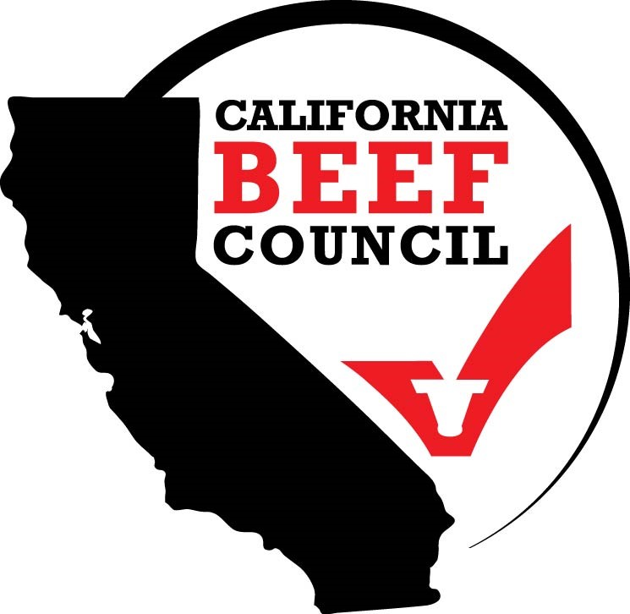
2026 WALT RODMAN ENTRY GUIDELINES
Entries Due Wednesday, September 30, 2026

ABOUT THE CONTEST
The Walt Rodman Award was established in 1982 to recognize outstanding beef promotion programs completed by California CattleWomen county units. Named in honor of long-time California Beef Council executive director Walt Rodman, who led the organization from 1957 until 1971, this award is intended to honor the innovative efforts of CattleWomen to share the cattle community’s story with the public and enhance beef’s overall image. All county units participating in the contest receive a cash award to help offset the costs of their promotion efforts.

THE AWARD
As in years past, the California Beef Council will award three runner-up and three first place awards to California CattleWomen units, based on unit membership size (one runner-up and one winner per membership category). First place winners will receive $400 and a certificate. Runners-up will receive $200 and a certificate, and all other units that entered the contest will receive a $50 award and a certificate.
The three membership categories* are:
- Up to 49 members
- 50 to 69 members
- 70 or more members
*Based on your unit's membership as of September 1, 2026.

ENTRY CRITERIA
Each unit may submit one entry; submitting more than one entry will result in disqualification from the contest. Qualified beef promotion projects must have been completed between October 1, 2025 and September 29, 2026.
The narrative portion of each entry should be typed, and the following criteria adhered to:
- Entries must include a completed cover sheet provided by the California Beef Council (this is the first page of the entry form).
- Entries may not exceed five pages for the written narrative portion. Additional pages may be included to provide examples of photos, publicity material, media coverage, etc. There is no limit on additional pages of these supplemental materials.
- Entries must be received by the California Beef Council no later than September 30, 2026, at 5 p.m. For example, entries postmarked on September 30 but not in the office by 5 p.m. on September 30 will be disqualified.
Entries will be judged based on the following criteria:
- Concept (20 points): Describe the project’s theme and overall objective, including information about why the unit chose the project. Also include what makes the project’s objective helpful in promoting beef and sharing the beef community’s story.
- Description (20 points): Provide a detailed description of the project, including specific project components, location or venue (if applicable), materials created or used in the project, and how beef was highlighted or promoted.
- Execution and Results (30 points): Provide metrics that help demonstrate how this project was successful. Examples include number of individuals reached, number of participants, amount of beef served (if it was a tasting event), social media outreach and engagement, media or news coverage and its potential reach, and any other objective metrics that show the project’s impact. Feedback from consumers or participants is also helpful to describe. Include photos, publicity materials, social media posts, and/or any news coverage generated by the project to support this section.
- Originality (15 points): Share details about how the concept was created and what the inspiration was for this project. For example, did your unit find a creative way to reach consumers in new and different ways? If the concept is similar to a project executed in other areas, describe how the unit made it unique or original.
- Adaptability (15 points): Include information that indicates what was needed for the successful execution of the promotional effort. For example, number of volunteers involved, the approximate number of hours involved, project budget, facilities or other special requirements, specific materials that were needed, and anything else involved that helps describe what is required to conduct such a project or event should be included.
- Bonus (10 points): This is your opportunity to share additional details about why your unit feels this promotion is uniquely qualified for the 2025 Walt Rodman Award.
Total possible points = 110

JUDGING PROCESS
Entries will be reviewed by qualified judges with expertise in communications, marketing, and/or public relations, who will analyze each entry based on the criteria and guidelines described under “Entry Criteria”. The judges are selected based on their background and experience, and their neutrality (i.e., not affiliated with any specific CCW unit).

PREVIOUS WINNERS
Alameda (1982, 1983, 1989, 1996, 2011, 2014, 2020)
Butte (2025)
Calaveras-Tuolumne (2018, 2019, 2023)
Humboldt (1984)
Intermountain (1992, 2001)
Kern (2007, 2008, 2009, 2011)
Lassen (2017, 2019, 2022, 2023)
Modoc (1986)
Placer-Nevada (1987, 2002, 2024)
Plumas-Sierra (2020)
San Benito (1998, 2000, 2017, 2018)
San Joaquin-Stanislaus (2003, 2020)
San Luis Obispo (1991, 1992, 1994, 1995, 1997, 1999, 2004, 2022, 2024, 2025)
Santa Barbara (1990)
Santa Clara (2017)
Shasta (1985, 1988, 2005, 2006, 2016, 2021, 2022, 2025)
Siskiyou (2012, 2019, 2023)
Tehama (2013, 2021, 2024)
Tulare (2010, 2015, 2018, 2021)
Additional questions? Please contact Annette Kassis or Bill Dale with the CBC at annette@calbeef.org or bill@calbeef.org, or 916.925.2333.
Good luck!

